PRISM – Day 6 Work Report
Day 6: Backend & API Foundation
1. Day 6 Objective
The main objective of Day 6 was to establish the backend and API foundation for PRISM – Procurement Risk Intelligence & Supplier Management.
The focus was on understanding how the frontend communicates with the backend, how API rules are defined, how system components interact, and how procurement entities move through valid business states.

2. REST API Design
What is REST API?
REST (Representational State Transfer) is an architectural approach for designing web APIs. REST APIs commonly use HTTP methods to perform operations on resources.
Main HTTP Methods
Method | Purpose | PRISM Example
GET | Retrieve data | GET /suppliers
POST | Create data | POST /quotations
PUT | Replace/update data | PUT /suppliers/{id}
PATCH | Partially update data | PATCH /quotations/{id}/status
DELETE | Delete data | DELETE /suppliers/{id}
PRISM API Examples
GET /suppliers
GET /suppliers/{id}
POST /quotations
GET /quotations/{id}
PATCH /quotations/{id}/status
GET /risk/suppliers
REST API design provides a structured way for the React frontend and FastAPI backend to communicate.

3. API Contract
What is an API Contract?
An API Contract is an agreement between the frontend and backend that defines how they communicate.
It specifies:
- Endpoint
- HTTP method
- Request format
- Response format
- Required fields
- Data types
- Error responses
- Authentication requirements
Example
For creating a quotation:
POST /quotations
Request:
{
"supplier_id": 25,
"product_id": 101,
"quantity": 5000,
"unit_price": 125.50,
"delivery_date": "2026-09-20"
}
Response:
{
"quotation_id": 501,
"status": "Quotation Received",
"message": "Quotation created successfully"
}
The contract ensures that both frontend and backend expect the same structure.
Common API Documentation
API contracts can be documented using:
- OpenAPI
- Swagger
- JSON Schema
FastAPI can generate OpenAPI/Swagger documentation automatically.

4. Sequence Diagram
What is a Sequence Diagram?
A Sequence Diagram is a UML interaction diagram that shows how actors and system components communicate in a particular order over time.
It answers:
Who communicates with whom, and in what order?
Main Elements
- Actor – external user or system
- Participant – system component involved in the interaction
- Lifeline – vertical line representing the participant
- Message – communication between participants
- Activation – period during which a participant is processing a request
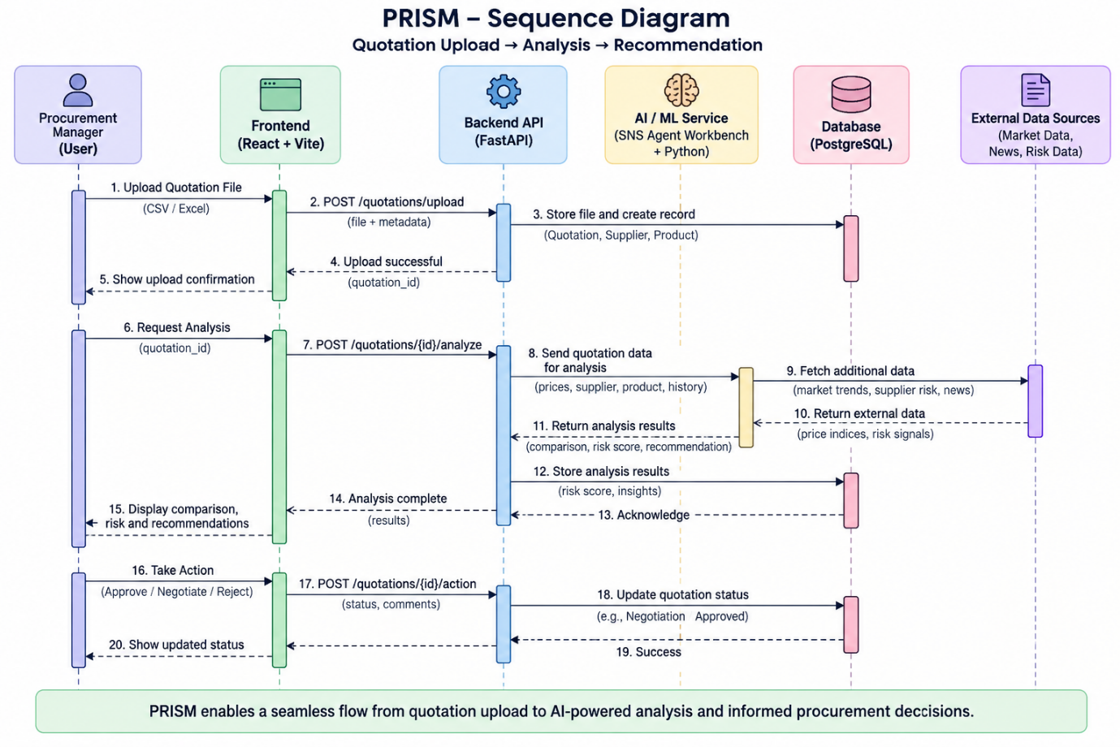
The sequence diagram represents the order of interactions, not just the overall architecture.

5. State Transition
What is State Transition?
A state transition describes how an entity moves from one valid state to another because of an event or action.
Basic concept:
Current State + Event/Action → New State
PRISM Quotation Lifecycle
RFQ Created
|
| Send RFQ
↓
RFQ Sent
|
| Supplier submits quotation
↓
Quotation Received
|
| Start evaluation
↓
Under Evaluation
|
├──────────────→ Negotiation
| |
| ├── Accept → Approved
| |
| └── Reject → Rejected
|
├── Accept → Approved
|
└── Reject → Rejected
State Transition Table
Current State | Event/Action | Next State
RFQ Created | Send RFQ | RFQ Sent
RFQ Sent | Supplier submits | Quotation Received
Quotation Received | Start evaluation | Under Evaluation
Under Evaluation | Start negotiation | Negotiation
Under Evaluation | Accept | Approved
Under Evaluation | Reject | Rejected
Negotiation | Accept | Approved
Negotiation | Reject | Rejected
Invalid Transitions
RFQ Created → Approved ❌
RFQ Sent → Approved ❌
Rejected → Negotiation ❌
Approved → RFQ Created ❌
The backend should enforce these rules so that the quotation lifecycle remains consistent and traceable.

6. Backend Service Foundation
What is Backend Service Foundation?
The backend service foundation is the initial structure required to build and operate the application's backend.
For PRISM, the foundation includes:
React / Vite
↓
FastAPI Backend
↓
+-----------------------+
| API Endpoints |
| Business Logic |
| Authentication |
| Authorization / RBAC |
| Database Connectivity |
| Service Organization |
+-----------------------+
↓
PostgreSQL
Main Responsibilities
API Handling: Receives requests from the frontend and returns responses.
Database Connectivity: Communicates with PostgreSQL to store and retrieve procurement data.
Business Logic: Applies procurement rules such as valid quotation state transitions.
Authentication: Verifies the identity of the user.
Authorization / RBAC: Determines what an authenticated user is allowed to access or modify.
Example:
Procurement Manager → Risk analysis + supplier approval
Procurement Analyst → Quotation analysis
Operations → Supplier profile management
Supplier → Own RFQs / quotations

7. PRISM Backend Flow
The Day 6 backend foundation can be understood as:
User
↓
React / Vite
↓
FastAPI
↓
REST API
↓
Business Logic
↓
PostgreSQL
For AI-powered analysis:
FastAPI
↓
SNS Agent Workbench
↓
Python ML / Intelligence
↓
Analysis Result
↓
FastAPI
↓
React

8. Day 6 Project Work – Quotation Lifecycle
The team reviewed the quotation lifecycle and identified permitted and invalid state transitions.
Workflow
RFQ Created
↓
RFQ Sent
↓
Quotation Received
↓
Under Evaluation
↓
Negotiation
↓
Approved / Rejected
Team Work Areas
- Define RFQ and quotation status rules
- Design quotation status and supplier evaluation screens
- Implement quotation state-transition logic
- Maintain quotation history, revision, approval and negotiation data

9. Wireframe
A UI Wireframe is a basic visual blueprint of a user interface created before the final UI design.
It focuses on:
- Information placement
- Navigation
- Inputs
- Buttons
- Tables
- Main screen sections
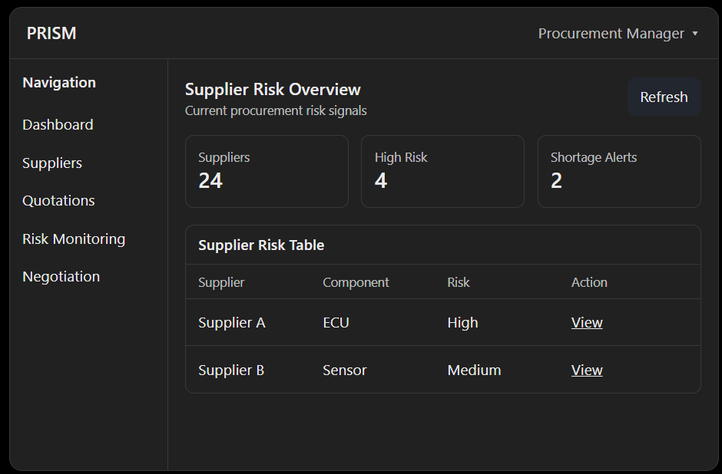
The wireframe is not the final visual design. It is used to validate the screen structure and user flow early.
10. Key Learning
The main Day 6 concepts form one connected workflow:
Backend Foundation
↓
REST API
↓
API Contract
↓
Component Communication
↓
Sequence Diagram
↓
Business Rules
↓
State Transition
Key Takeaway
REST API defines how components communicate.
API Contract defines what both sides agree to exchange.
Sequence Diagram shows the order of communication.
State Transition defines how a business entity moves between valid states.
Backend Service Foundation provides the APIs, business logic, database connectivity, authentication and authorization needed to implement these concepts.

Day 6 Memory Chain
Backend → API → Contract → Sequence → State
Build the backend → expose REST APIs → define the contract → show communication using sequence diagrams → enforce valid state transitions.

